Warning – Charge Port Door Ajar – BEV_PHEV – CGEA1.3

Functional Description

The purpose of the Warning – Charge Port Door Ajar – BEV_PHEV STSS is to inform that the charge port door is open. This functionality is applicable only for BEV and PHEV. If the driver opens the charge port door intentionally, so as to use for charging or to check the port, the notification should not be displayed.

This Charge Port Door Ajar Warning correlates ChrgPortDrOpen_B_Stat, PwPckTqRdy_B_Dsply signals and Operational Mode to display the appropriate warning in the message center.

Interfaces

Interface Context Diagram (I/O Block Diagram)
- Charge Port Door Ajar Warning
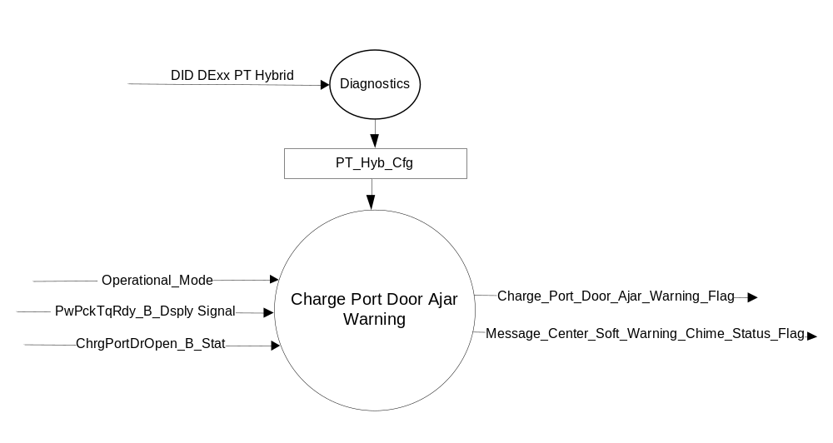

Inputs
- INTERNAL:

Operational_Mode

- MUX Signals on CAN bus
- PwPckTqRdy_B_Dsply Signal Details
Signal Name | Size (bits) | Detail | Units | Res. | Offset | State Encoded | Min | Max
PwPckTqRdy_B_Dsply | 1 |  | SED | 1 | 0 |  | 0 (0x0) | 1 (0x1)
 |  | Off |  |  |  | 0x0
 |  | On |  |  |  | 0x1

- ChrgPortDoorPos_B_Actl Signal
Signal Name | Size (bits) | Detail | Units | Res. | Offset | State  Encoded | Min | Max
ChrgPortDrOpen_B_Stat | 1 |  | SED | 1 | 0 |  | 0 (0x0) | 1 (0x1)
 |  | False |  |  |  | 0x0
 |  | True |  |  |  | 0x1

Outputs
- Charge_Port_Door_Ajar_Warning_Flag used to control the Warning displayed in the message center that informs about Charge Port Door Ajar
- Message_Center_Soft_Warning_Chime_Status_Flag, which is used to control the state of the chime to the Chime Arbitrator

Function/Performance

Operational Modes
Mode | Differentiating Vehicle Conditions
Sleep Mode | “Charge Port Door Ajar” Warning is off
Limited Mode | “Charge Port Door Ajar” Warning is off
Normal Mode | “Charge Port Door Ajar” Warning is on/off
Crank Mode | “Charge Port Door Ajar” Warning is on/off

Voltage Levels

Refer to the Cluster Features table located in the Operational Modes and Voltage Range Strategies section in this SPSS

Human-Machine Interface

Visual

Indicator Graphics / Display Format

W3576 – “Charge Port Ajar”

Message Center Text Warning Message as defined in section 1.3.5.7 of this document. Actual wording may vary based on Program Translation table.

Indicator Color Coordinates

Amber - Reference section COLOR & ILLUMINATION REQUIREMENTS (GRAPHICS)

Audio

Message_Center_Soft_Warning_Chime will be played to active if Charge_Port_Door_Ajar_Warning_Flag is active

Switch Control Logic

Not Applicable

System Accuracy

The message should be re-displayed on subsequent ignition key transitions to the run/start position if the ready indication command is true.

Operation: Performance and Functional

Subsystem Algorithm Flowchart / State Diagram
- Transmission Type Determination
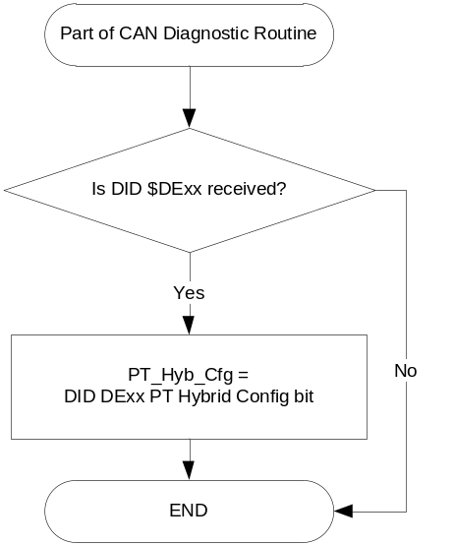
- “Charge Port Door Ajar” Set Active Warning Flowchart
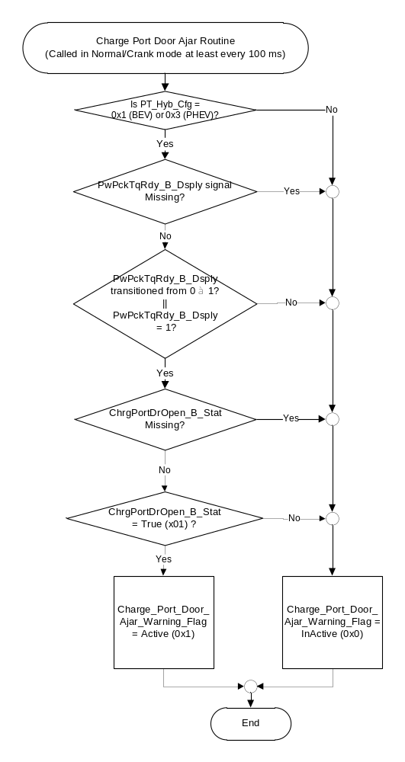

Design Note for Figure above (Not a requirement, but an FYI for understanding):
We do not guarantee that the HPCM will always broadcast at least one value of PwPckTqRdy_B_Dsply = 0 in key run/start prior to sending a value of 1. The solution is to either monitor for this transition any time the bus is awake (i.e. in all key cycles), or to initialize the signal to 0 on transition from OFF/ACC to RUN/START. We chose the latter.

Operation Description (supports algorithm flowchart /state diagram)

- “Charge Port Door Ajar” Active Warning Flag
Charge Port Door Ajar  Active Warning Flags | Warning # Displayed | Chime
Charge_Port_Door_Ajar_Warning_Flag = Active (0x1) | W3576 | Message_Center_Soft_Warning_  Chime

- If the Torque to set the vehicle in ready to drive mode is not available, do not display any notification
- Intentionally opening the charge port door does not trigger the warning
- The following use cases are provided for better understanding of the functionality:
  - If the Plug is disconnected and if the ignition is RUN/START, Vehicle is ready to drive and if the condition for Charge Port Door Ajar is True(0x1), then the notification is to be displayed
  - Off plug, charge port door OPEN, Ignition is RUN/START, Vehicle is ready to drive, display notification
  - Off plug, charge port door is OPEN, Ignition is OFF, no notification
  - On plug, charge port door is OPEN, Ignition is RUN/START, no notification
  - On plug, charge port door is OPEN, Ignition is OFF, no notification
  - Off plug, charge port door is CLOSED, no notifcation

Function Safety Classification (EMC)

B

Memory Storage
Parameter Name | Description | Value at  Battery Connect | Value at  Module Wake-up | Value at  Transition to Normal/Crank Mode From Limited Mode
Operational_Mode | 4 state indicator for cluster operational mode | Limited | Limited, Normal or Crank | Limited, Normal or Crank
PwPckTqRdy_B_Dsply Signal | CAN signal sent from GWM for “Ready to Drive” State | 0x0 | 0x0 | 0x0
ChrgPortDrOpen_B_Stat | CAN signal from HPCM to indicate the Charge Port Door Ajar Status | 0x0 | 0x0 | 0x0
Charge_Port_Door_Ajar_Warning_Flag | used to control the Warning displayed in the message center | Inactive | Inactive | Inactive
Message_Center_Soft_Warning_  Chime_Status_Flag | Used to control the state of the chime to the Chime Arbitrator | Inactive | Inactive | Inactive

Prove Out

No

Reconfigurable Telltale

No

Message Center Msg

W3576 – “Charge Port Ajar”
Refer Warning Message as defined in the Text Message List section of this SPSS

Error Handling

Missing Message Strategy

CAN signals will be declared missing as per the Diagnostics section of this SPSS.

DTCs states and history will be determined as per the Diagnostics section of this SPSS.

Diagnostics

Self Test

None

Engineering Test Mode
None

Part II Performance

Supported Diagnostic Trouble Codes (DTCs)
DTC | Description
C29300 | Lost Communication with HPCM

DID DEXX
Block  Num | Block Description | Size (bits) |  | Byte(s) | Bits | State: Description | Default | Comments/  Information
PACKETED BLOCKS
$00 | Option Content (B&A) |  |  | * | 2 | PT_Hyb_Cfg  0x0 = Non-Hybrid  0x1 = BEV  0x2 = FHEV  0x3 = PHEV | 0x0 = Non-Hybrid | Default from cluster plant to be 0x0 if cluster can be used on a Non-Hybrid.

Reference Specification

IS-0001 WARNINGS/INDICATORS/DISPLAYS PROVEOUT
IS-0052 OPERATING VOLTAGES - FUNCTIONAL/PERFORMANCE
IS-0069 FUNCTIONAL IMPORTANCE CLASS
IS-0324 WINDSHIELD & OTHER REFLECTIONS
IS-0327 WARNING INDICATOR EVALUATION
IS-0379 NORTH AMERICAN WARNINGS AND INDICATORS STRATEGY

IL-0017 TELLTALE AND INTERIOR ILLUMINATION – COLOR AND INTENSITY
IL-0019 GENERAL ILLUMINATION DIMMING
IL-0021 CRAFTSMANSHIP – DISPLAYS
IL-0022 GENERAL ILLUMINTATION COLOR
IL-0023 CLARITY/LEGIBILITY/READABILITY/VISUAL CONTRAST
IL -0043 OPERATIONAL ENVIRONMENT FUNCTIONALITY
IL -0045 COLOR
IL -0047 TELLTALE, INDICATOR AND DISPLAY LIGHT INTENSITY
IL -0048 ILLUMINATION ACCEPTABILITY

03-0661 PLACEMENT: CONTROL AND DISPLAY LOCATIONS
03-0662 PLACEMENT: LOGICAL GROUPING FUNCTION AND USAGE
03-0664 PLACEMENT: DOWN VISION TO COMPONENTS WITH HIGH VISUAL DEMAND
03-0665 PLACEMENT: EXPECTED LOCATIONS OF CONTROLS AND DISPLAYS VDS
03-0670 INTERIOR VISIBILITY
03-0671 INTERIOR VISIBILITY: REFLECTIONS FROM COMPONENTS & SURFACES
03-0672 INTERIOR VISIBILITY: REFLECTIONS IN DISPLAYS
03-0673 INTERIOR VISIBILITY: VISUAL OBSCURATIONS
03-0674 INTERIOR VISIBILITY: ILLUMINATION CONTROLS / DISPLAYS
03-0675 INTERIOR VISIBILITY: VEILING GLARE
03-0677 INTERIOR VISIBILITY: SUNLIGHT WASHOUT
03-0681 IDENTIFICATION: CHARACTER AND SYMBOL SIZE
03-0682 IDENTIFICATION: LEGIBILITY
03-0685 IDENTIFICATION: SYMBOLS, ABBREV FOR CONTROL
03-0721 LOGIC OF OPERATION: OPERATIONAL STEREOTYPES
03-0722 LOGIC OF OPERATION: INTERPRETATION
03-0723 LOGIC OF OPERATION: USE OF SYSTEMS WITH VISUAL DISPLAYS

Driver Information Display Control (DIDC), Version 3.8

Subsystem Specific Diagnostic Specification (Part 2) (GMRDB_*.xls – Refer Latest)

Diagnostic Fault Coverage and DTC Numbers Design Considerations (Document # 00.06.15.601)

Revision History

STSS Module Revision History
Revision Level | Name | Change Description | Date
1.0 | R. Chalanti | Initial Revision based on request from Carpenter,Toussaint , Gilman,Dale and Esler, Craig (EPE Team) to show Charge Port Door Ajar when the user forgets to close it | 10/7/2016

